**INDIAN CENSUS – 2011**

SQL PROJECT

**Q1. Number of rows into our dataset1**

SELECT COUNT(*) AS Total_RowsDS1 FROM Dataset1;

SELECT COUNT(*) AS Total_RowsDS2 FROM Dataset2;

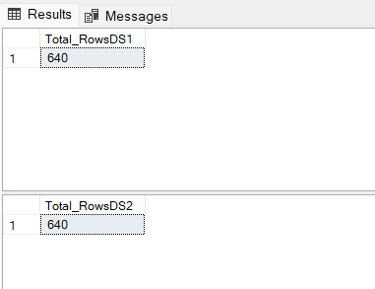

**Q2. Dataset for Specific state**

SELECT * FROM Dataset1

WHERE State in ('Kerala');

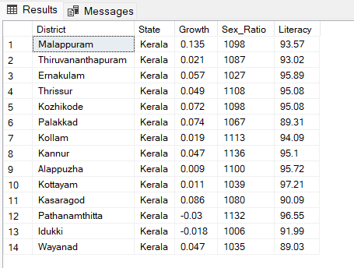

SELECT * FROM Dataset1

WHERE State in ('Kerala','Tamil Nadu','Bihar');

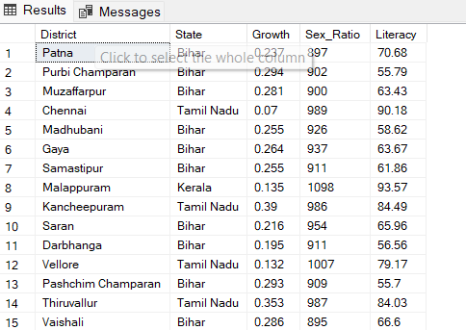

**Q3. Population of India**

SELECT SUM(Population)Total_Population FROM Dataset2;

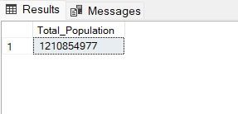

**Q4. Average growth rate**

SELECT AVG(Growth)AVG_Growth FROM Dataset1;

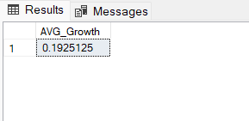

**Q5. Average growth rate by State**

SELECT State,(AVG(Growth)*100)AVG_Growth FROM Dataset1

GROUP BY State;

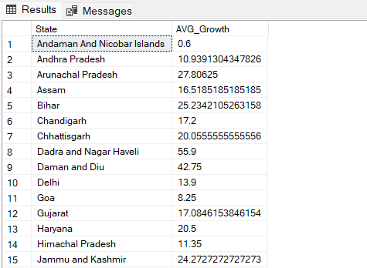

**Q6. Average sex ratio by Top 10 State**

SELECT TOP 10 State, AVG(Sex_Ratio)AVG_Sex_Ratio FROM Dataset1

GROUP BY State

ORDER BY AVG_Sex_Ratio DESC;

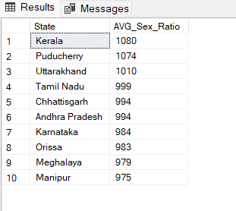

**Q7. Average sex ratio by Bottom 10 State**

SELECT Top 10 State,AVG(Sex_Ratio)AVG_Sex_Ratio

FROM Dataset1

GROUP BY State

ORDER BY AVG_Sex_Ratio ASC;

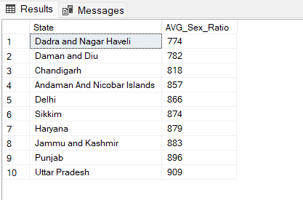

**Q8. Average Literacy rate by State**

SELECT State,ROUND( AVG(Literacy),2)AVG_Literacy_rate

FROM Dataset1

GROUP BY State

HAVING ROUND( AVG(Literacy),2)> 85

ORDER BY AVG_Literacy_rate DESC;

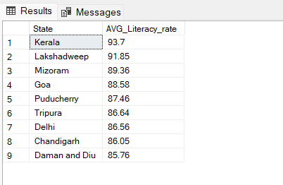

**Q9. Top 3 State showing highest growth ratio**

SELECT TOP 3 State,ROUND((AVG(Growth)*100),1)AVG_Growth_Rate

FROM Dataset1

GROUP BY State

ORDER BY AVG_Growth_Rate DESC;

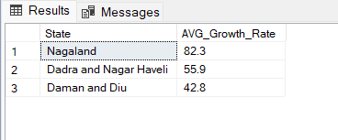

**Q10. Bottom 3 State showing Lowest growth ratio**

SELECT TOP 3 State,ROUND((AVG(Growth)*100),1)AVG_Growth_Rate

FROM Dataset1

GROUP BY State

ORDER BY AVG_Growth_Rate ASC;

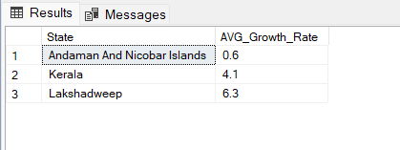

**Q11. Top and bottom 3 states in literacy state**

DROP TABLE IF EXISTS #Topstates;

CREATE TABLE #Topstates

(State nvarchar(50),

Topstates float

)

INSERT INTO #Topstates

SELECT TOP 3 State, ROUND(AVG(Literacy),2)AVG_Literacy_rate

FROM Dataset1

GROUP BY State

ORDER BY AVG_Literacy_rate DESC;

SELECT * FROM #Topstates

DROP TABLE IF EXISTS #Bottomstates;

CREATE TABLE #Bottomstates

(State nvarchar(50),

Bottomstates float

)

INSERT INTO #Bottomstates

SELECT Top 3 State,ROUND(AVG(Literacy),2)AVG_Literacy_rate

FROM Dataset1

GROUP BY State

ORDER BY AVG_Literacy_rate ASC;

SELECT * FROM #Bottomstates

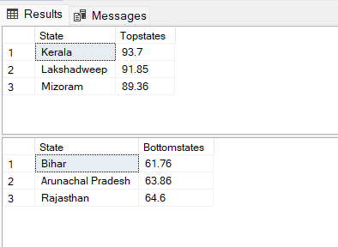

**Q12. Union Operator**

SELECT * FROM #Topstates

UNION

SELECT * FROM #Bottomstates

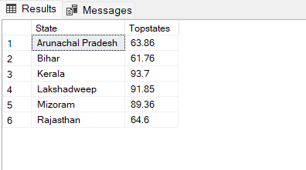

**Q13. Joining both Table**

SELECT Dataset1.District,Dataset1.State,Dataset1.Sex_Ratio,Dataset2.Population

FROM Dataset1

INNER JOIN Dataset2 ON Dataset1.District = Dataset2.District

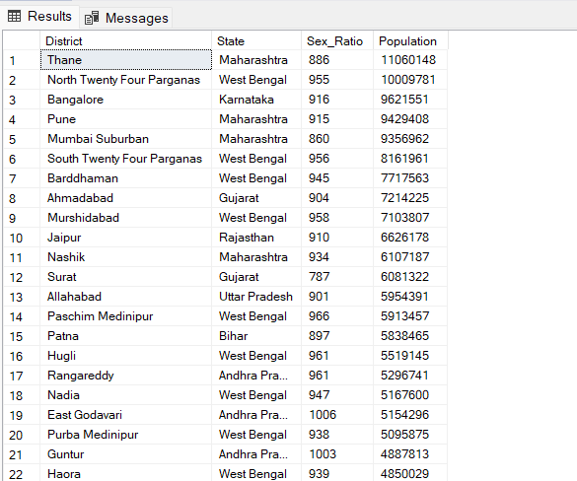

**Q14. Total males and females**

**Number of females = Total population * Sex ratio / (1000 + Sex ratio)**

**Number of males = Total population - Number of females**

SELECT DATA2.State,

SUM(DATA2.Females)AS Total_females,

SUM(DATA2.Males)AS Total_males

FROM

(SELECT DATA1.District,DATA1.State,

ROUND(DATA1.Population * DATA1.Sex_Ratio / (1000 + DATA1.Sex_Ratio),0) AS Females,

ROUND(DATA1.Population-(DATA1.Population * DATA1.Sex_Ratio / (1000 + DATA1.Sex_Ratio)),0) AS Males

FROM

( SELECT Dataset1.District,Dataset1.State,Dataset1.Sex_Ratio,Dataset2.Population

FROM Dataset1

INNER JOIN Dataset2 ON Dataset1.District = Dataset2.District) AS DATA1)AS DATA2

GROUP BY DATA2.State

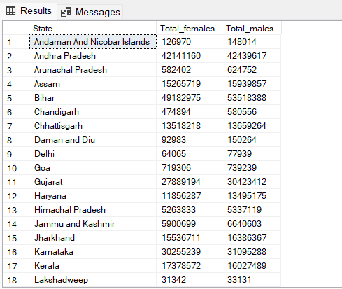

**Q15. Find number of Literate and Illiterate people**

**Total number of literate people = Total population * (Literacy rate / 100)**

SELECT D2.State,

SUM(D2.Total_literate_people) AS Literate_people,

SUM(D2.Total_illiterate_people) AS Illiterate_people

FROM

(SELECT D1.District, D1.State, D1.Population,

ROUND((D1.Population*D1.Literacy/100),0) AS Total_literate_people,

ROUND(D1.Population-(D1.Population*D1.Literacy/100),0) AS Total_illiterate_people

FROM

(SELECT Dataset1.District,Dataset1.State,Dataset1.Literacy,Dataset2.Population

FROM Dataset1

INNER JOIN Dataset2 ON Dataset1.District = Dataset2.District) AS D1) AS D2

GROUP BY D2.State

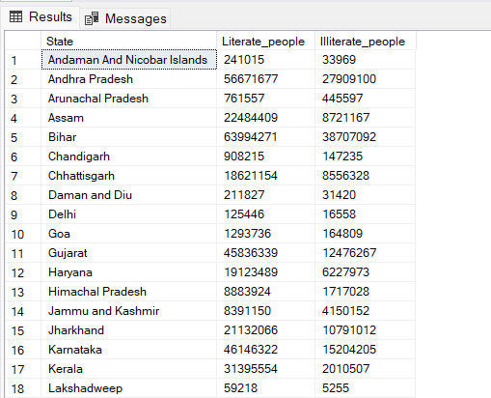

**Q16. Find Population in previous census**

**Previous population = Current population / (1 + (Growth rate / 100))**

SELECT SUM(D3.Previous_Population)AS Previous_Population,

SUM(D3.Current_Population)AS Current_Population

FROM

(SELECT D2.State,

SUM(D2.Previous_Population) AS Previous_Population,

SUM(D2.Population) AS Current_Population

FROM

(SELECT D1.District,D1.State,

ROUND(D1.Population/(1+D1.Growth_Rate/100),0)AS Previous_Population,

D1.Population

FROM

(SELECT Dataset1.District,Dataset1.State,(Dataset1.Growth*100)AS Growth_Rate,Dataset2.Population

FROM Dataset1

INNER JOIN Dataset2 ON Dataset1.District = Dataset2.District) AS D1)AS D2

GROUP BY State)D3

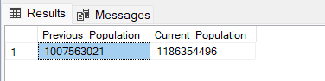

THANK YOU